CURRICULUM VITAE
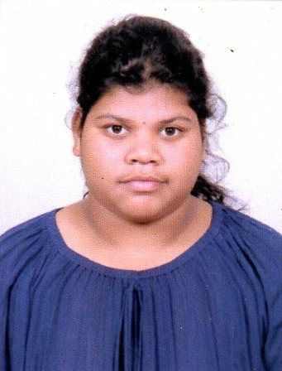

NAME : SASMITA SETHI
FATHERS NAME : MATIA SETHI
Cell No : 8895548264
E-Mail Id : sethisasmita2000@gmail.com

PRESENT & PERMANENT ADRESS:
AT : QR-NO-RA-744,HAL TOWNSHIP
POST : SUNABEDA-2
DIST : KORAPUT
STATE : Odisha
PIN : 763002

Career Objectives:
Seeking a challenging environment and job calling for team work which encourages continuous learning and creativity providing exposure to new ideas and simulates personal & professional growth.

Academic Qualification:
EXAMINATION | DISCIPLINE/ SPECIALIZAION | BOARD/UNIVERSITY | YEAR OF PASSING | PERCENTAGE  (%)
MATRICULATION | ALL | BSE ODISHA | 2015 | 45.83
+2 | COMMERCE | CHSE ODISHA | 2017 | 37.17
+3 | BCOM | BERHAMPUR UNIVERSITY | 2020 | 62.70
P. G | M. Com | F. M autonomous college | 2021 | Continue

Software Skill:
PGDCA COMPLETE FROM OCTAL,TALLY COURSE .

Personal Details:
Date of Birth : 02/03/2000
Cast : SC
Marital Status : Single
Gender : Female
Nationality : Indian
Language Known : Oriya, English and Hindi

Strengths/Traits and Skills:

- Ability to assume various roles within a team, including thought leadership.
- Honest, sincere and hard working.
- Good communication skills, creative and adapt
Declaration:
I hereby declare that the information given in the application is true, complete and correct to the best of my knowledge and belief. I understand that in the event of any information being false or incorrect at any stage; my candidature shall be liable for cancellation/termination.

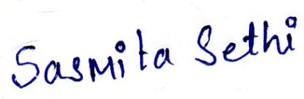

Place: - sunabeda-2, hal township Signature of the Candidate
Date:-01/09/2021

